# Lab: Dictionaries, Lambda and LINQ

Problems for exercises and homework for the ["Technology Fundamentals" course @ SoftUni](https://softuni.bg/courses/technology-fundamentals).

You can check your solutions here: <https://judge.softuni.bg/Contests/1212>

# Associative Arrays

## Count Real Numbers

Read a **list of integers** and **print them in ascending order** along with their **number of occurrences**.

### Examples

|  |  |  |  |  |  |  |  |
| --- | --- | --- | --- | --- | --- | --- | --- |
| **Input** | **Output** |  | **Input** | **Output** |  | **Input** | **Output** |
| 8 2 2 8 2 | 2 -> 3  8 -> 2 | 1 5 1 3 | 1 -> 2  3 -> 1  5 -> 1 | -2 0 0 2 | -2 -> 1  0 -> 2  2 -> 1 |

### Hints

Read an array from doubles

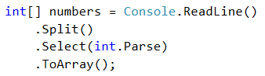

Use SortedDictionary<double, int> named counts.



Pass through each input number num and increase counts[num] (when num exists in the dictionary) or assign counts[num] = 1 (when num does not exist in the dictionary).

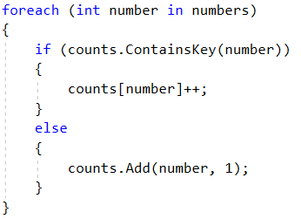

Pass through all numbers in the dictionary and print the number num and its count of occurrences.

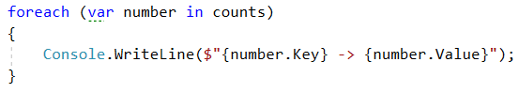

## Odd Occurrences

Write a program that extracts from a given sequence of words all elements that present in it **odd number of times** (case-insensitive).

* Words are given in a single line, space separated.
* Print the result elements in lowercase, in their order of appearance.

### Examples

|  |  |
| --- | --- |
| **Input** | **Output** |
| Java C# PHP PHP JAVA C java | java c# c |
| 3 5 5 hi pi HO Hi 5 ho 3 hi pi | 5 hi |
| a a A SQL xx a xx a A a XX c | a sql xx c |

### Hints

Read a line from the console and split it by a space



Use a **dictionary** (string 🡪 int) to count the occurrences of each word



Pass through all elements in the array and count each word.

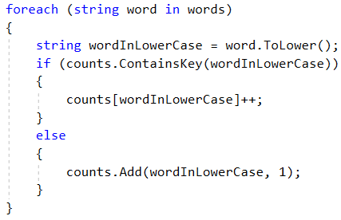

Pass through the dictionary and print words that occures odd times.

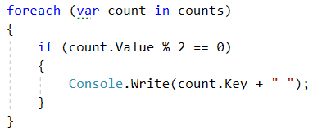

## Word Synonyms

Write a program which keeps a dictionary with synonyms. The **key** of the dictionary will be the **word**. The **value** will be a **list of all the synonyms of that word**. You will be given a number **n**. On the next **2 * n** lines you will be given a **word** and a **synonym** each on a separate line like this:

* {**word**}
* {**synonym**}

If you get the same word twice just add the new synonym to the list.

Print the words in the following format:

**{word} - {synonym1, synonym2… synonymN}**

### Examples

|  |  |
| --- | --- |
| **Input** | **Output** |
| 3  cute  adorable  cute  charming  smart  clever | cute - adorable, charming  smart - clever |
| 2  task  problem  task  assignment | task – problem, assignment |

### Hints

* Use **dictionary (string -> List<string>)** to keep track of all words



* **Read n * 2 lines**
* **Add the word in the dictionary if it is not present**

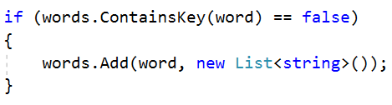

* **Add the synonym as value to the given word**



* **Print each word with the synonyms in the required format**

# LINQ

## Largest 3 Numbers

Read a **list of integers** and **print largest 3 of them**. If there are less than 3, print all of them.

### Examples

|  |  |  |  |  |
| --- | --- | --- | --- | --- |
| **Input** | **Output** |  | **Input** | **Output** |
| 10 30 15 20 50 5 | 50 30 20 | 20 30 | 30 20 |

### Hints

* Read an array of integers
* **Order the array using LINQ query**

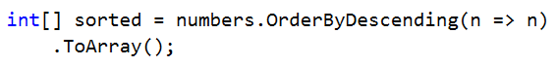

* **Print top 3 numbers with for loop**

## Word Filter

Read an array of strings, take only words which length is even. Print each word on a new line.

### Examples

|  |  |
| --- | --- |
| **Input** | **Output** |
| kiwi orange banana apple | kiwi  orange  banana |
| pizza cake pasta chips | cake |

* Read an array of strings
* Filter those whose length is even

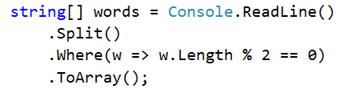

* Print each word on a new line